AIM
UPDATE AR INVOICE
MD.120 deployment Instructions
Raya International Services

Author: Varun Sai Kumar Jonna
Creation Date: JUNE 05, 2024
Last Updated:
Version: 1.0

Title, Subject, Last Updated Date, Reference Number, and Version are marked by a Word Bookmark so that they can be easily reproduced in the header and footer of documents. When you change any of these values, be careful not to accidentally delete the bookmark. You can make bookmarks visible by selecting Tools->Options…View and checking the Bookmarks option in the Show region.

Approvals:
<Approver 1>
<Approver 2>
To add additional approval lines, press [Tab] from the last cell in the table above.
 Copy Number _____
You can delete any elements of this cover page that you do not need for your document. For example, Copy Number is only required if this is a controlled document and you need to track each copy that you distribute.

Document Control

Change Record
3
Date | Author | Version | Change Reference
 |  | Ver 1.0

Reviewers

Name | Position

Distribution

Copy No. | Name | Location
The copy numbers referenced above should be written into the Copy Number space on the cover of each distributed copy. If the document is not controlled, you can delete this table, the Note To Holders, and the Copy Number label from the cover page.

Note To Holders:
If you receive an electronic copy of this document and print it out, please write your name on the equivalent of the cover page, for document control purposes.
If you receive a hard copy of this document, please write your name on the front cover, for document control purposes.
Contents
Document Control iii
Creating Connections For Integration 1
- Creation Of FTP Adapter. 1
- Creating of REST Adapter 2
Creating Integration 3
Run The Integration 19
Integration Tracking 20
Open and Closed Issues for this Deliverable 22
Open Issues 22
Closed Issues 22

To update the table of contents, put the cursor anywhere in the table and press [F9]. To change the number of levels displayed, select the menu option Insert->Index and Tables, make sure the Table of Contents tab is active, and change the Number of Levels to a new value.

Create Connections for SUPPLIER INVOICE INBOUND
Creation of adapters:
- To Create Supplier invoice, we are using two Adapters FTP and REST
- To create connections, navigate to connections tab and select create option then select desired adapter as shown below.
Adapter :- it helps to store the required credentials to make a connection.

Creation of ftp :
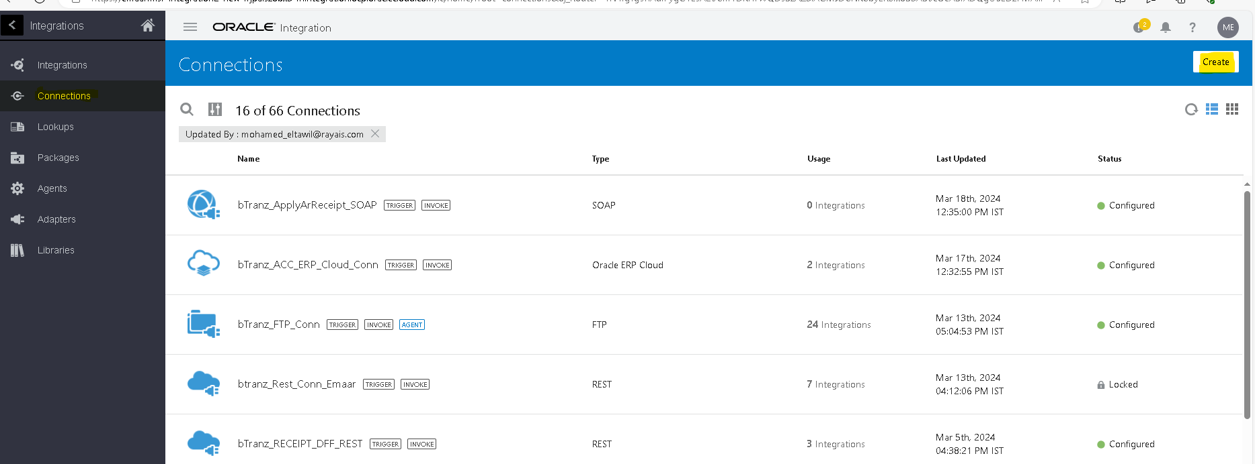
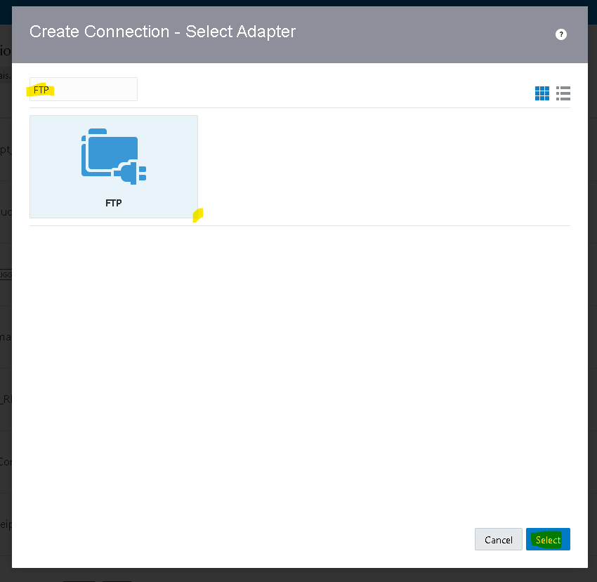
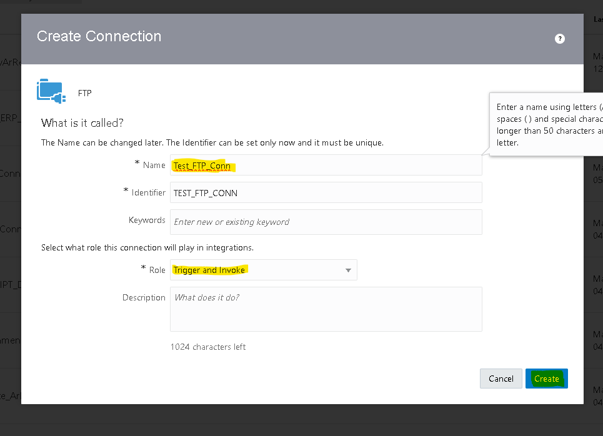

Connection role :- a trigger means the connection where the integration receives the message from. An invoke means the connection where the integration sends the message to.
- Based on our requirement we choose trigger and role connection
- After clicking on create we need to pass the required credentials as shown below
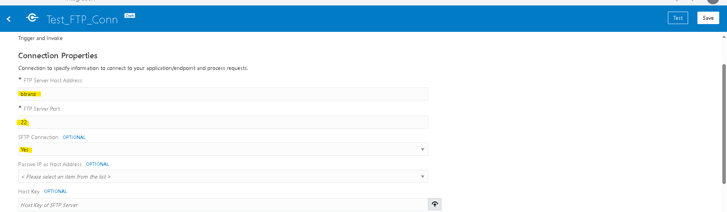
- Then click on test,popup will appear as shown above then select diagnose & test.
- After successful testing save your connection.
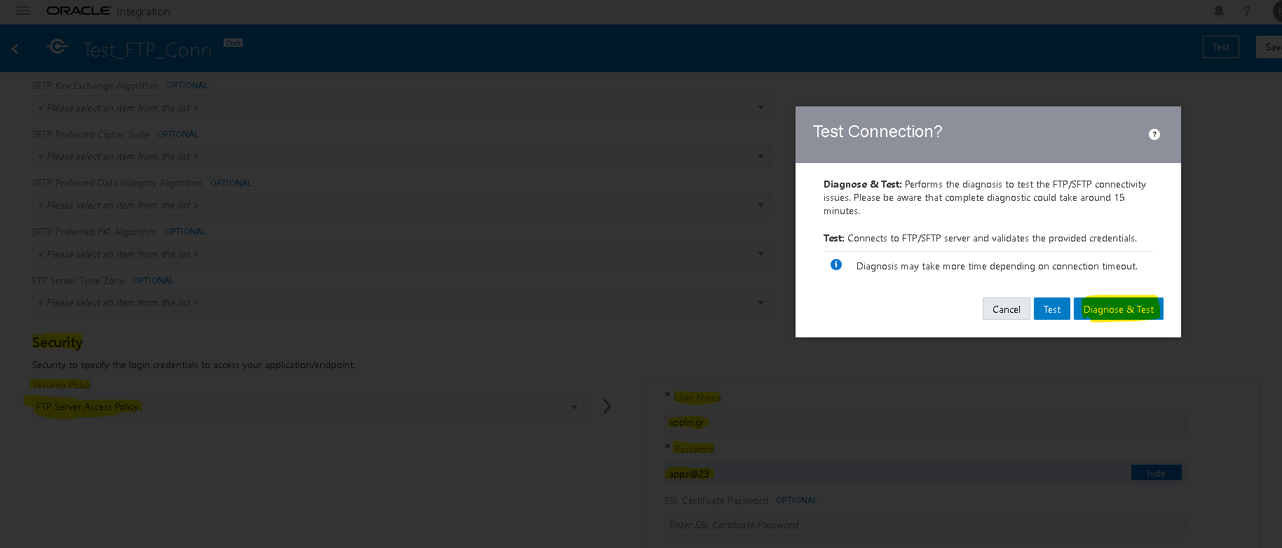
Creation of REST Connection:- Role Trigger And Invoke
- Navigate to connections tab then select the adapter based on the connection(rest)
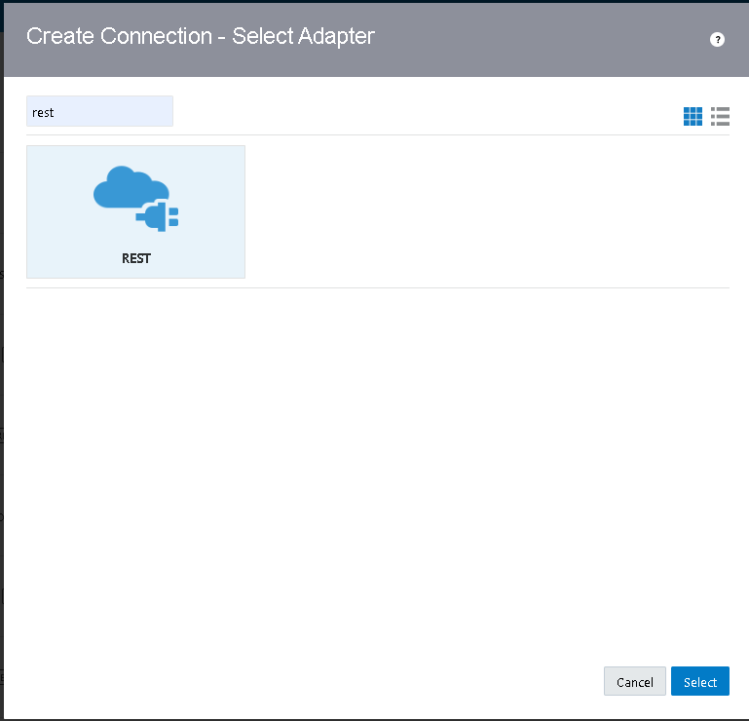
- Select connection type as rest api base url.
- Enter fusion base url as connection url.
- Select security as basic authentication and enter fusion credentails as username and password.
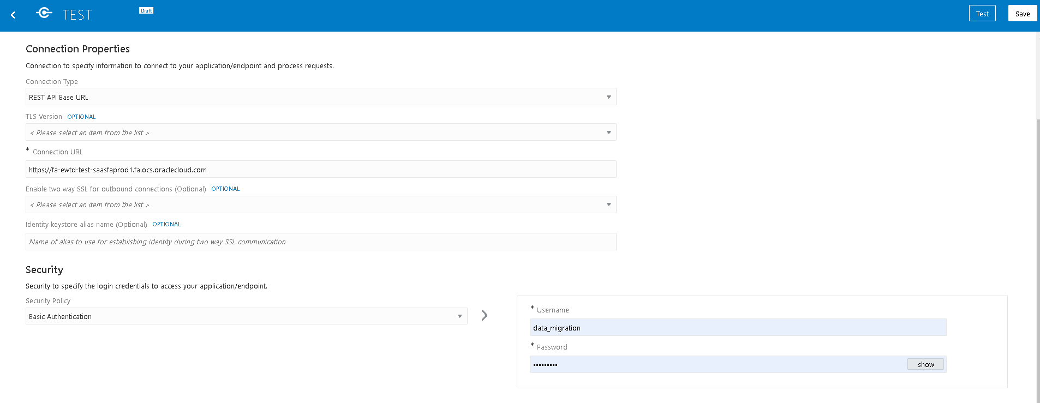
- Then click on test, after testing successfully save the connection.
Creation Of Integration:
- Navigate to integration tab then click on create option and select scheduled orchestration.
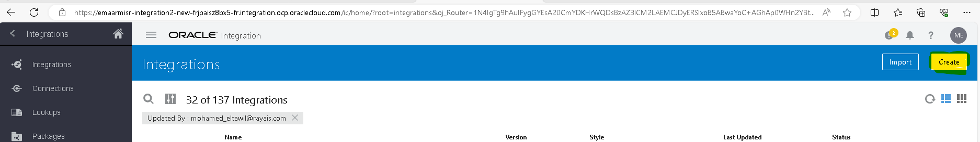
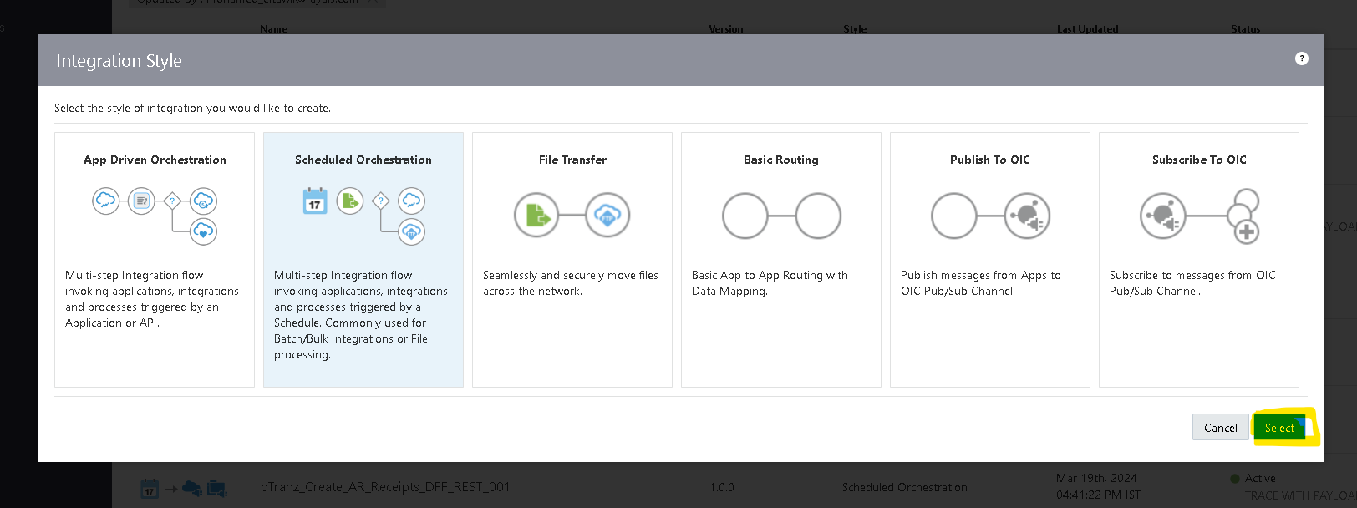

- Try to create with a unique name for identification.
- Once the integration is created select the action button on the right side of the Tab.
- Drag the Assign action and place it on plus (+) icon in the integration.
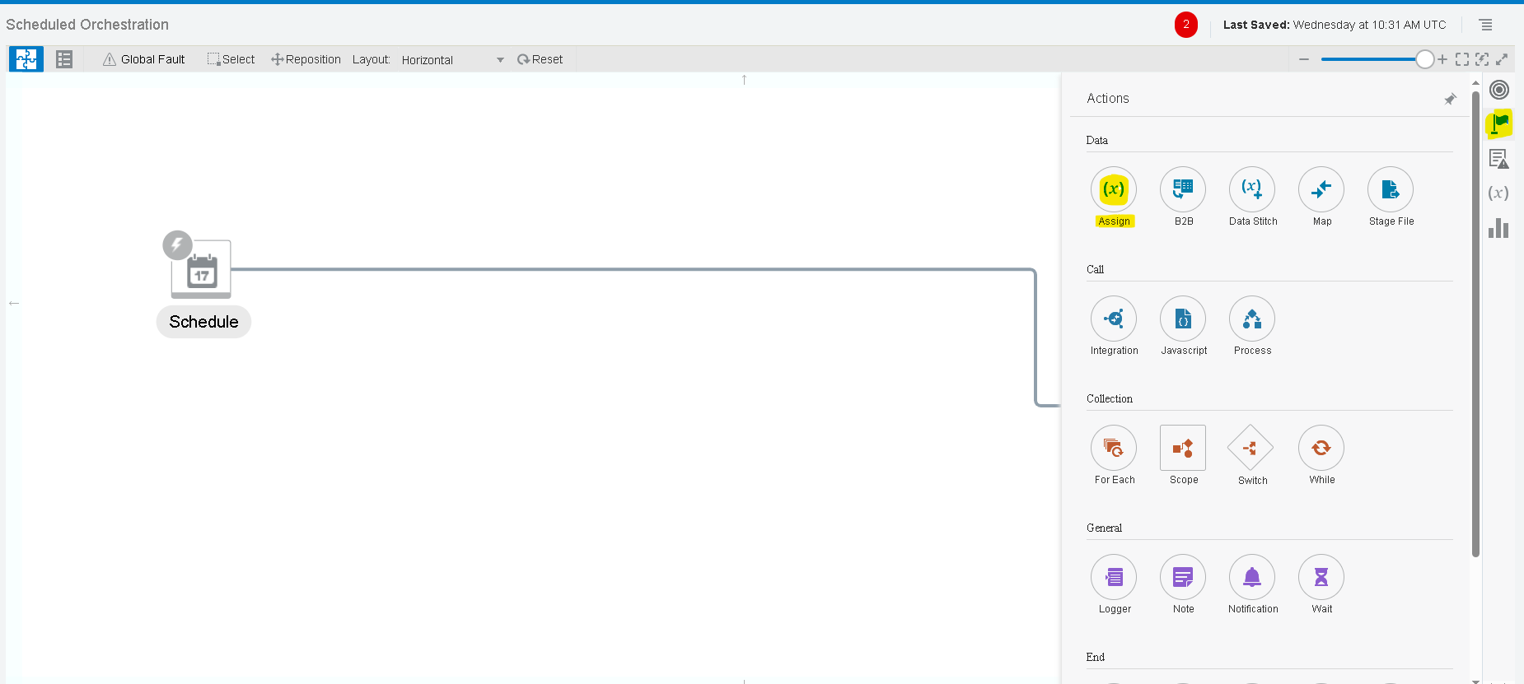
- Give a name for the assign action and click on create.
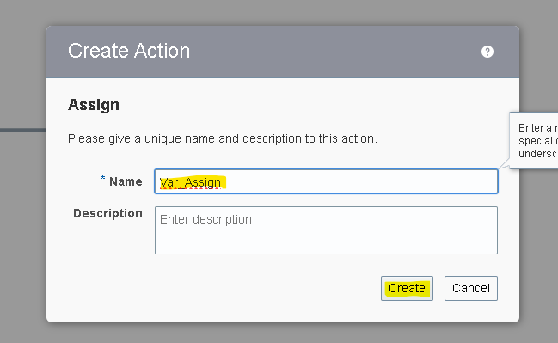
- Give the name of the variable and click on the pencil icon to assign the value for the variable.
- To add one more variable you can select plus (+) icon.
Note :- To Assign/Mention The Values We Need To Use Single Quotes .

Here we created One variable.
- UpadteDueDateFileRef

- Select the Plus (+) Icon and select the FTP adapter which we created earlier.
- we are using download operation of the ftp connection.
- The download operation allows us to download the file in OIC logical directory. It is the virtual directory which can only be used within that integration.
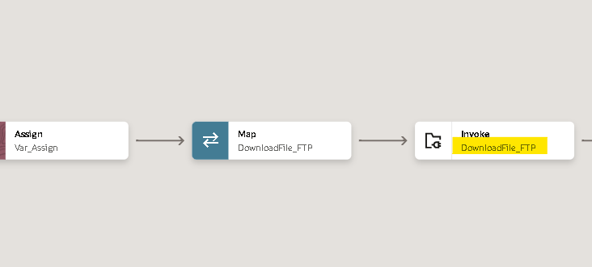
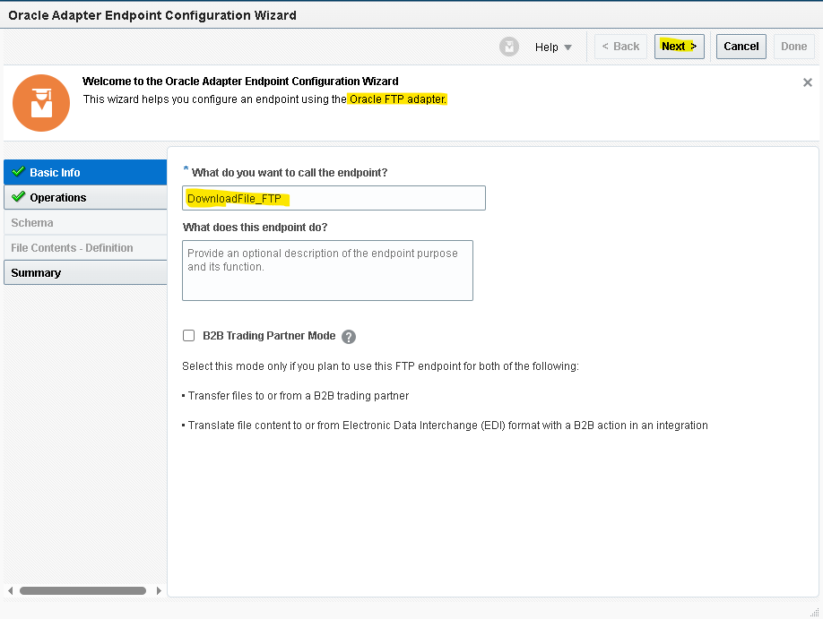

- Hardcode the value for directory and Filename and download directory.
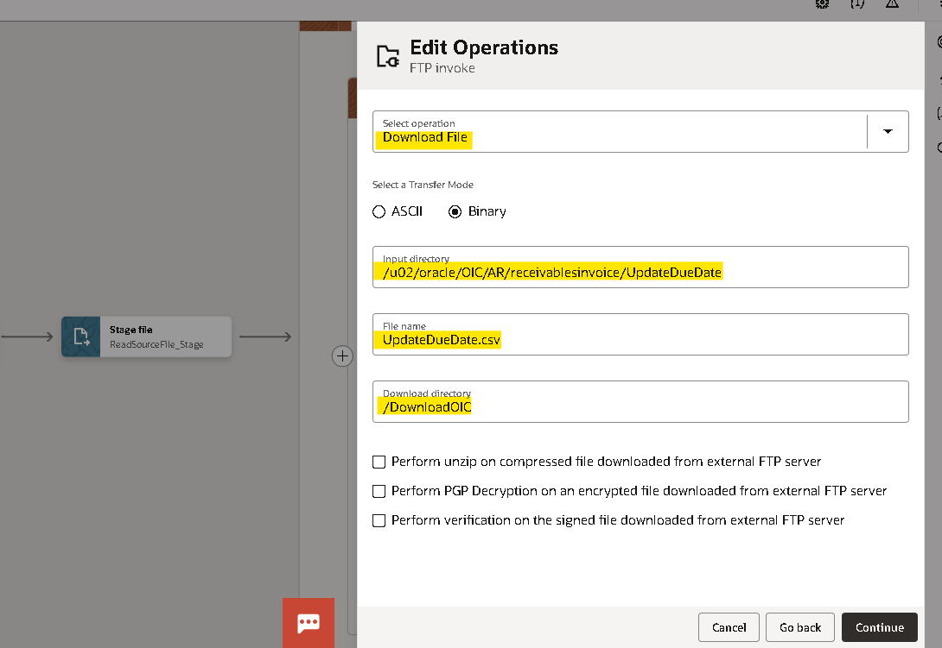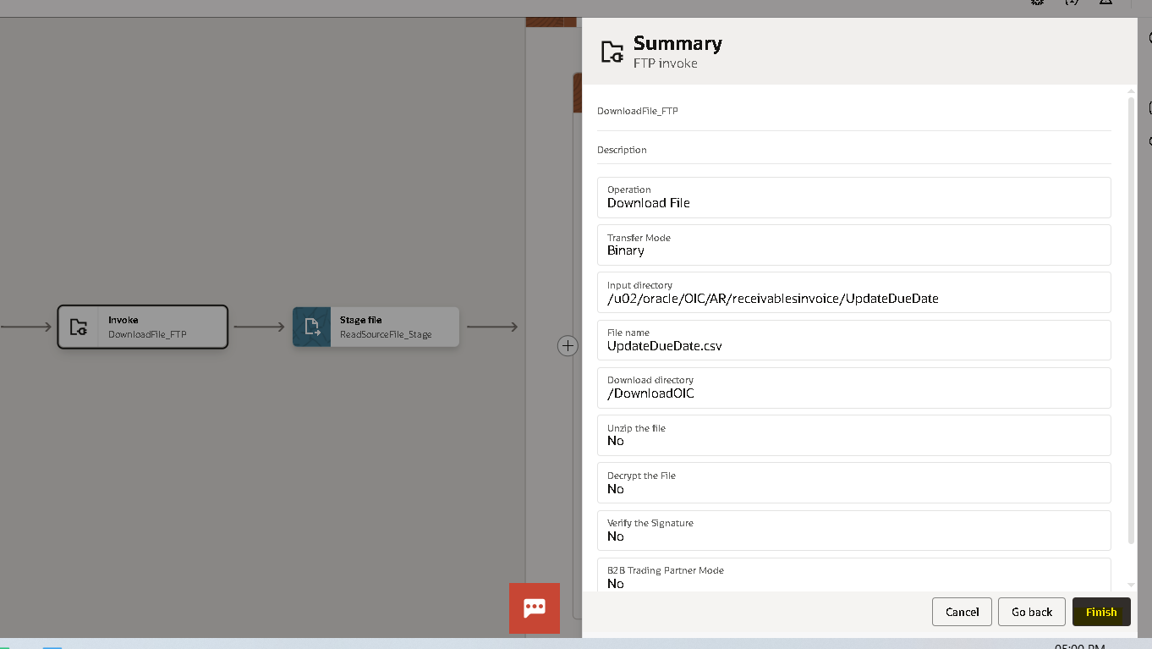
- Since we hard code the directory and file name we need not to edit mapper.
- Now we will use the stage activity to read the file from the response of the source file Download_Ftp.
- Search for ‘stage’ adapter by clicking on the plus (+) icon.
- Select the operation as ‘Read Entire File’. And configure file reference as yes.
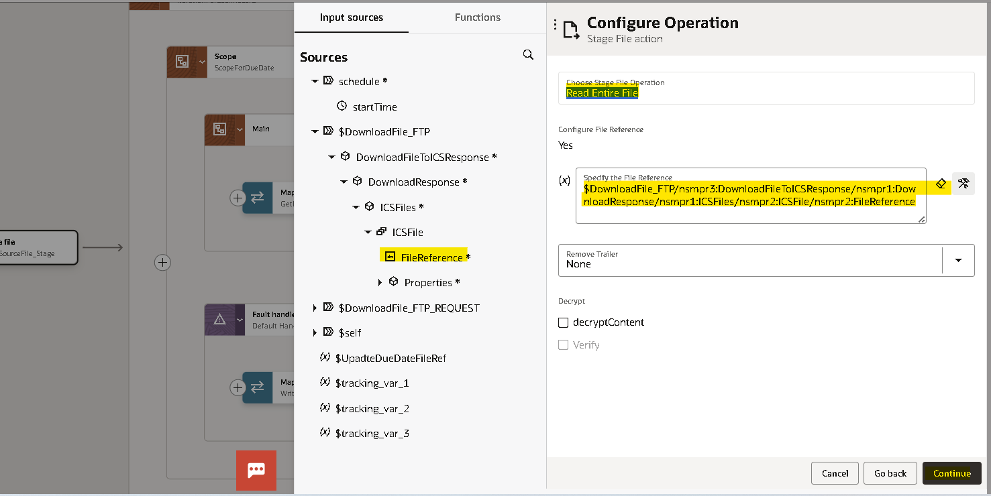
- Now we need to give the structure of the file content. As we are using the csv file select reference file from download response.

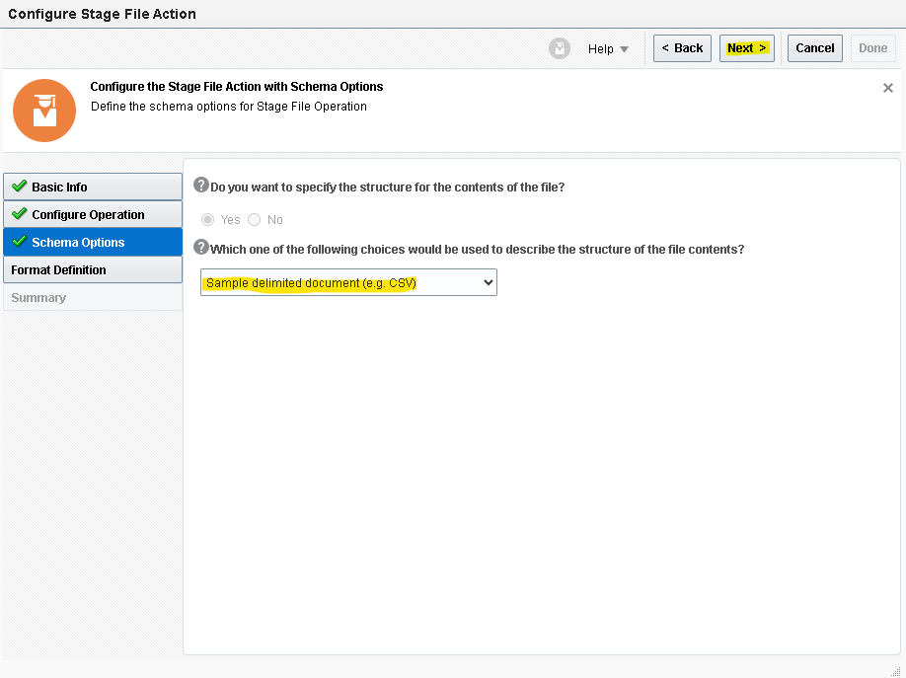
- We need to give sample structure format of the file which we will be downloaded from the ftp.
- Here chooses the file from your local desktop and you can mark all as optional but at least one column should be mandatory.
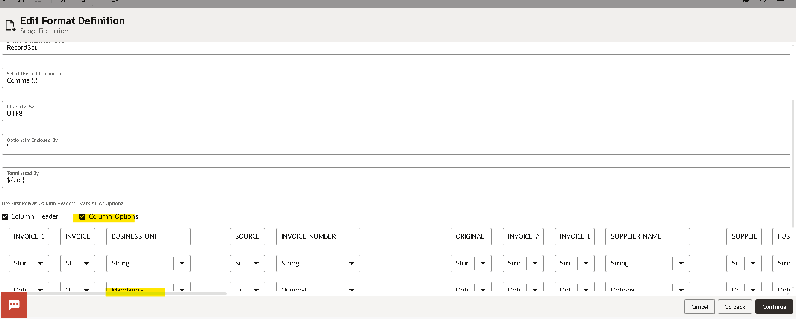

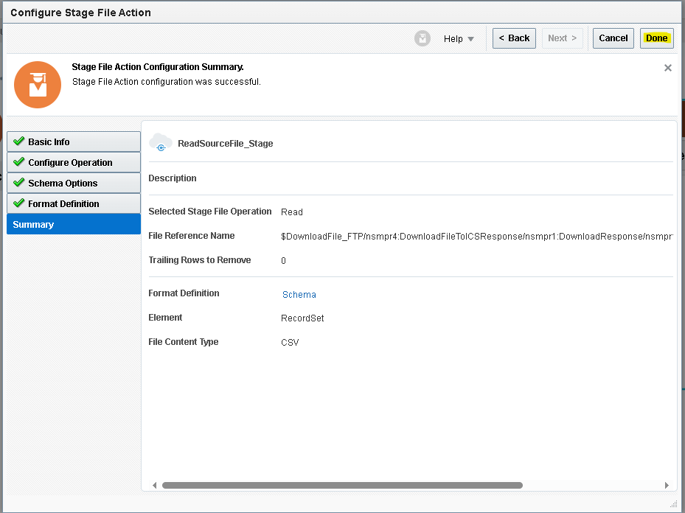

- Use for loop to iterate for every record read File response.
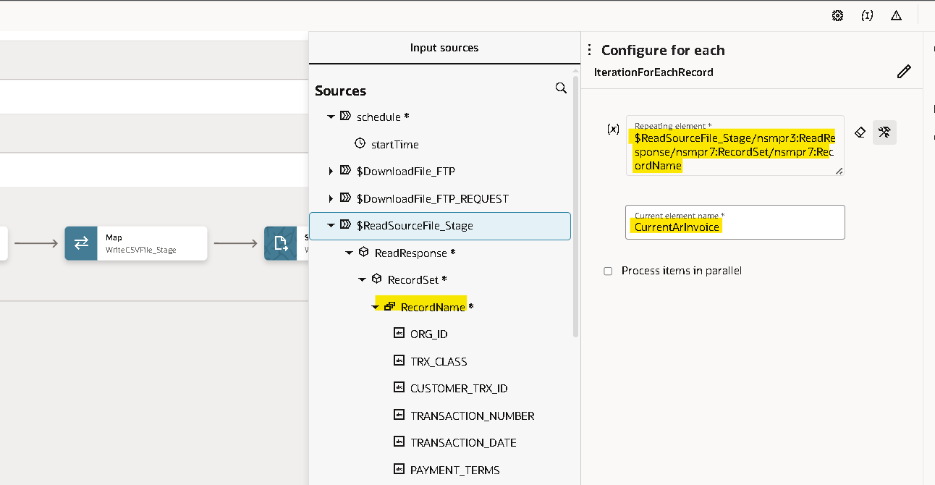
- Use the scope to handle the API errors.
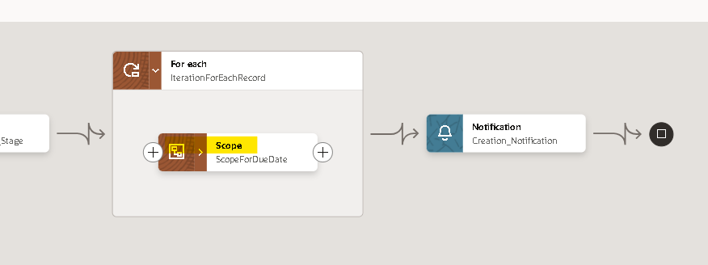
- Use rest adapter to send payload to the fusion.
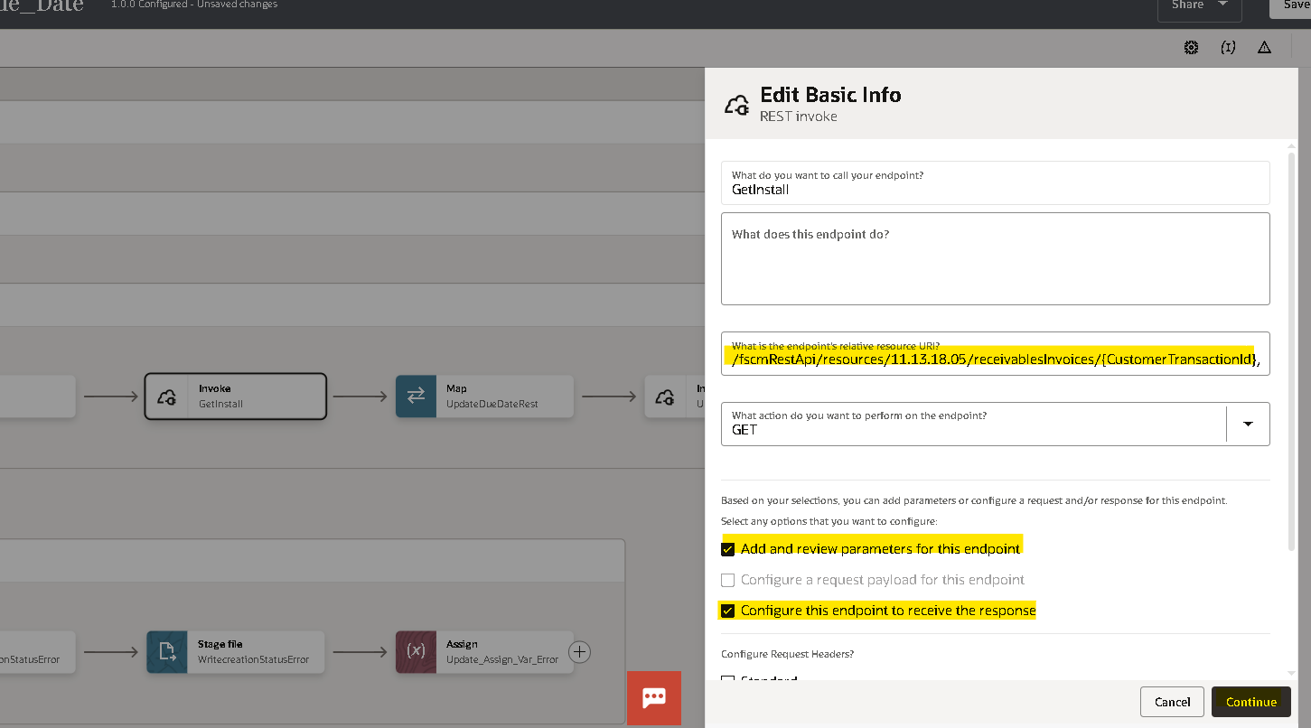
- Provide the Name for the end point , Paste the URI to Create AP Invoices and check the Response check boxes to configure request and response.
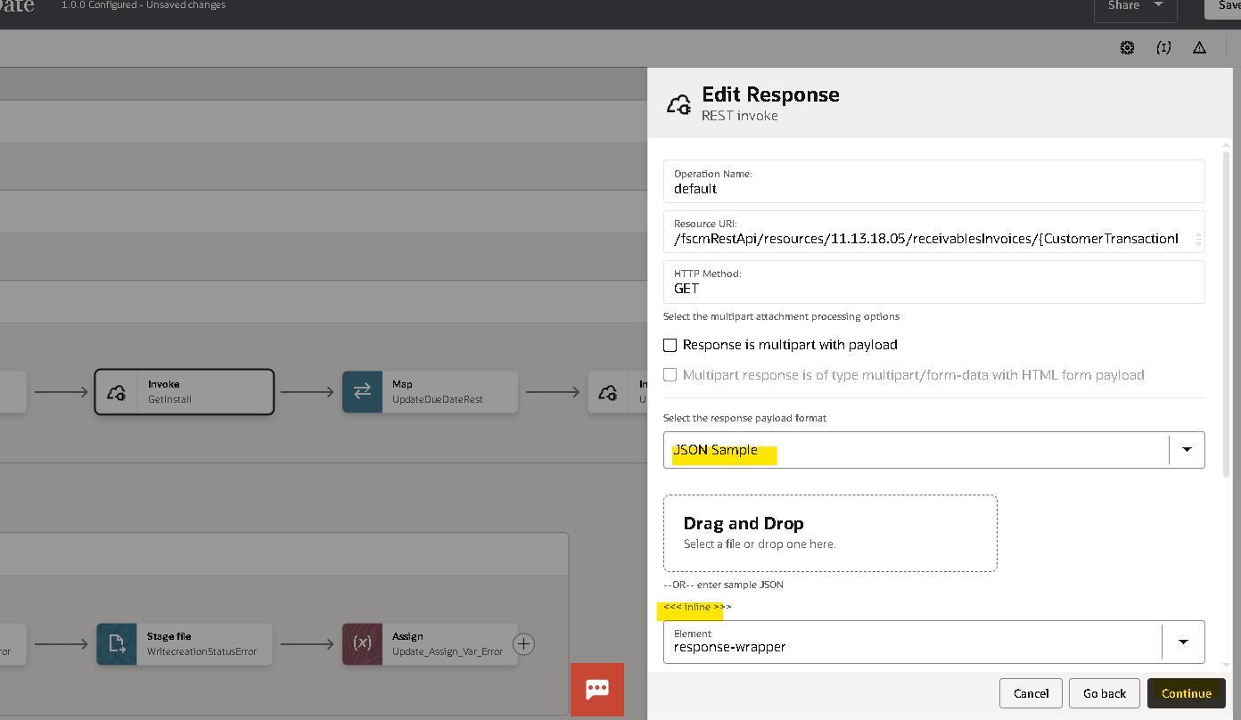
- Select the Response Format as JSON and paste the response payload.
{
"items" : [ {
"InstallmentId" : 159474,
"InstallmentSequenceNumber" : 1,
"InstallmentDueDate" : "2010-12-30",
"OriginalAmount" : 112588,
"PaymentDaysLate" : 4843,
"InstallmentBalanceDue" : 112588,
"InstallmentStatus" : "Open",
"DisputeAmount" : null,
"DisputeDate" : null,
"InstallmentClosedDate" : "4712-12-31",
"InstallmentGLClosedDate" : "4712-12-31",
"AccountedBalanceDue" : 112588,
"InstallmentAmountAdjusted" : null,
"InstallmentAmountCredited" : null,
"AmountPaid" : null,
"PendingAdjustmentAmount" : null,
"InstallmentLineAmountOriginal" : 112588,
"InstallmentLineAmountDue" : 112588,
"InstallmentFreightAmountOriginal" : 0,
"InstallmentFreightAmountDue" : 0,
"InstallmentTaxAmountOriginal" : 0
} ]
}
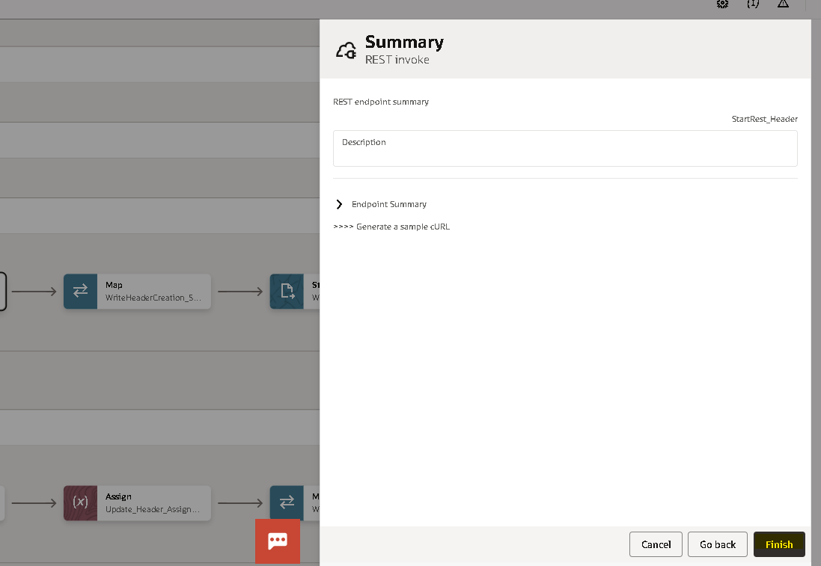
- Click on Finish mapper will generate automatically.
- Map the target parameters with the current record request payload.
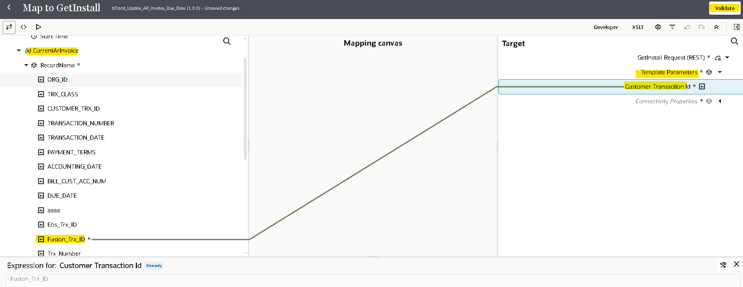
- Use the rest adapter again to update AR invoice based on the above response.
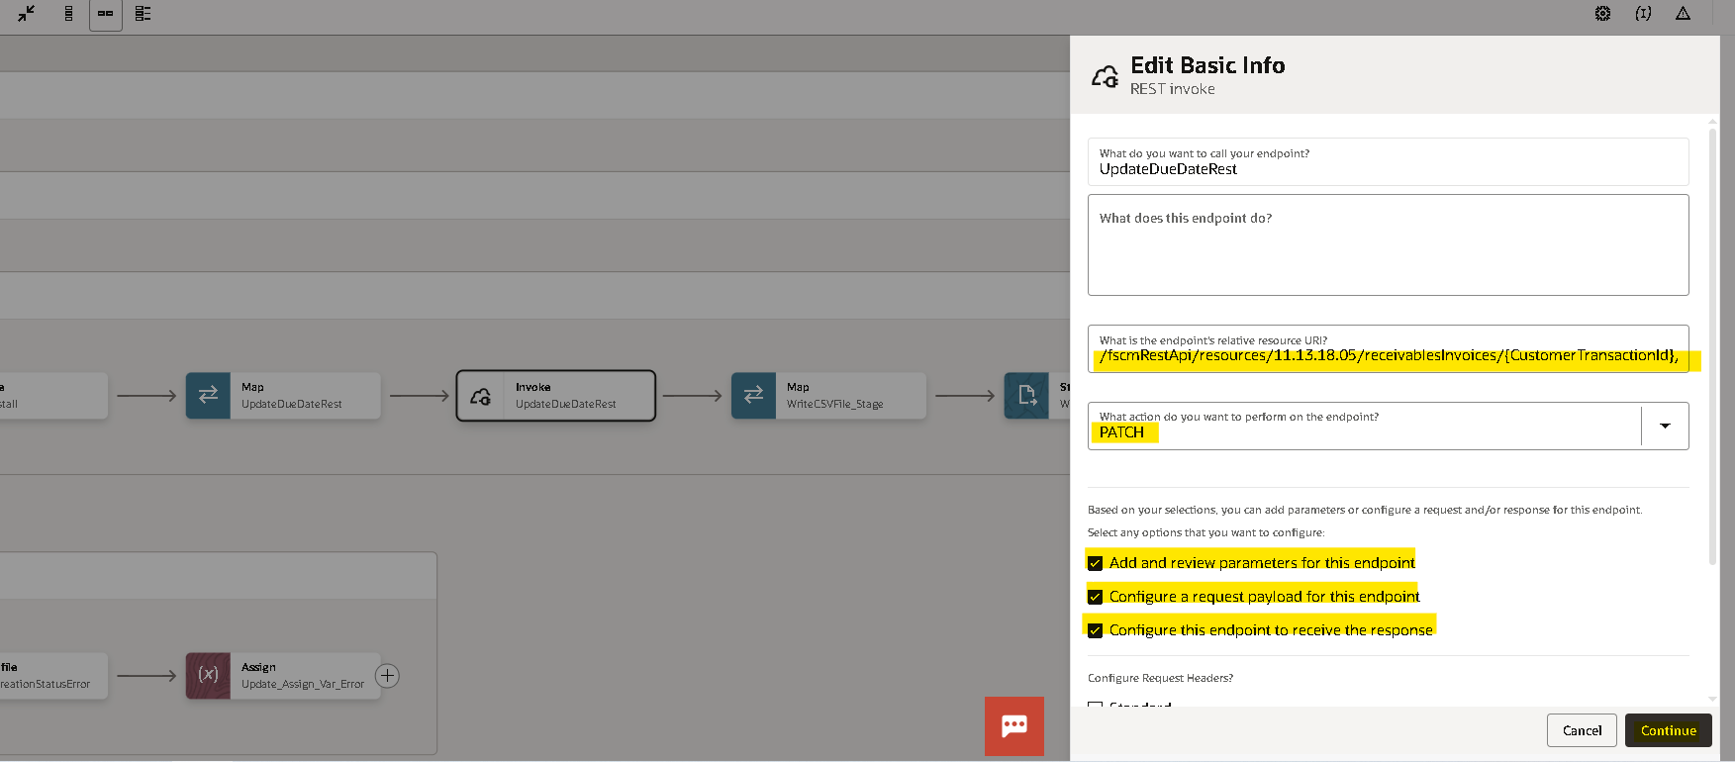
- Select the Request Format as JSON and paste the request payload
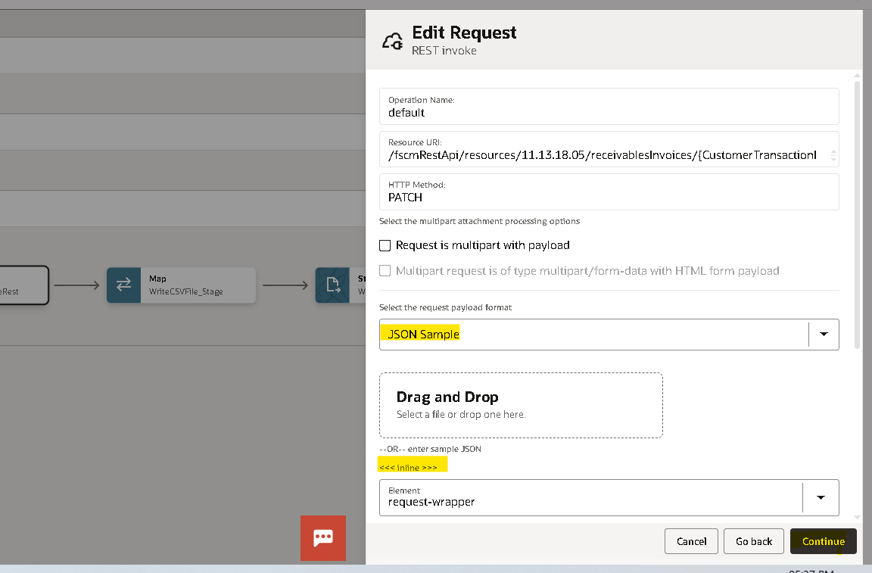
Request Payload:
{
"InstallmentDueDate" : "2015-03-03"
}
Similarly gave the response payload:
{
"STATUS" : "SUCCESS"
}
- Click on continue and finish
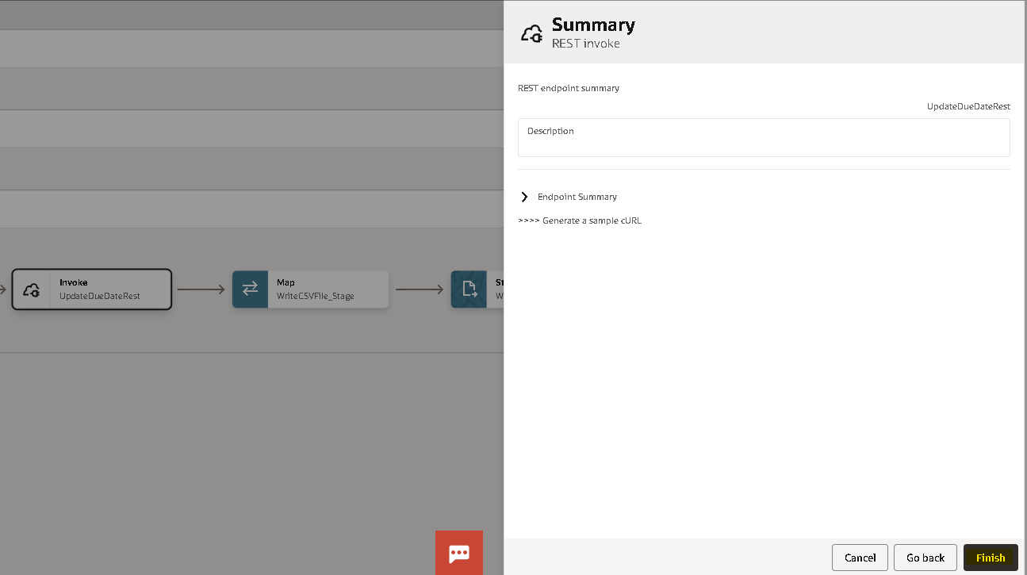
- Mapper will create automatically map the request payload element InstallmentDueDate from the current element and validate
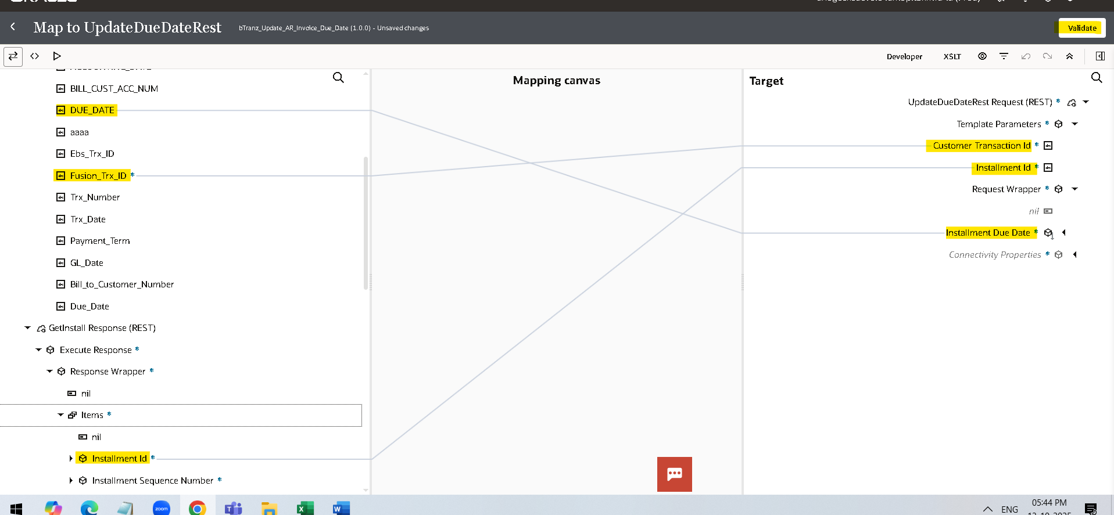

- we are using the stage write operation of the stage activity to update the FileReference variable with status and Error_Message columns.
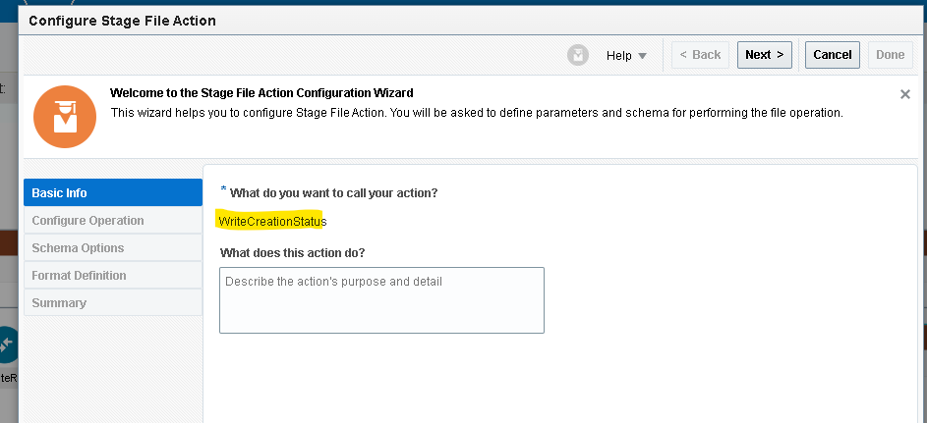
- Choose the file operation as writefile.
- Specify the file name and output directoty to store the file tempararly.
- Here we are using the option append to existing file which appends the every record to the file.
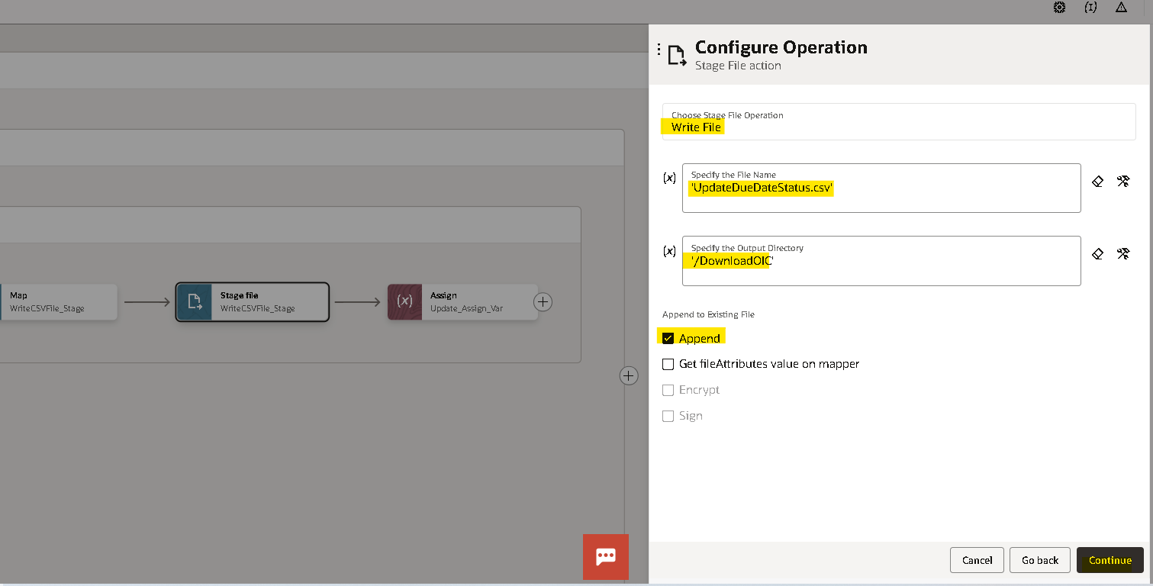
- Now we need to provide the structure of the file content here we are added two more columns in this file structure with ‘status and error message’.
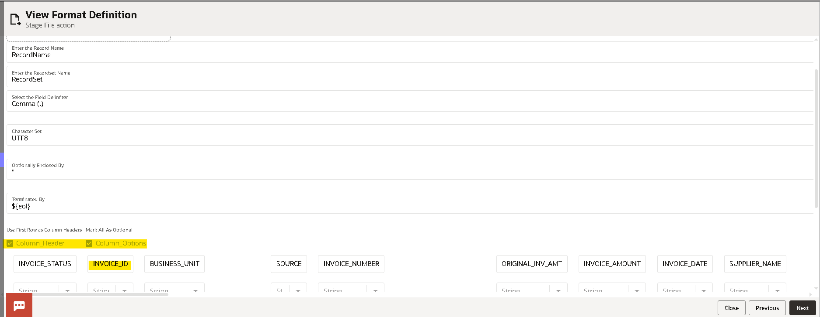

- Check the configuration and click on done.
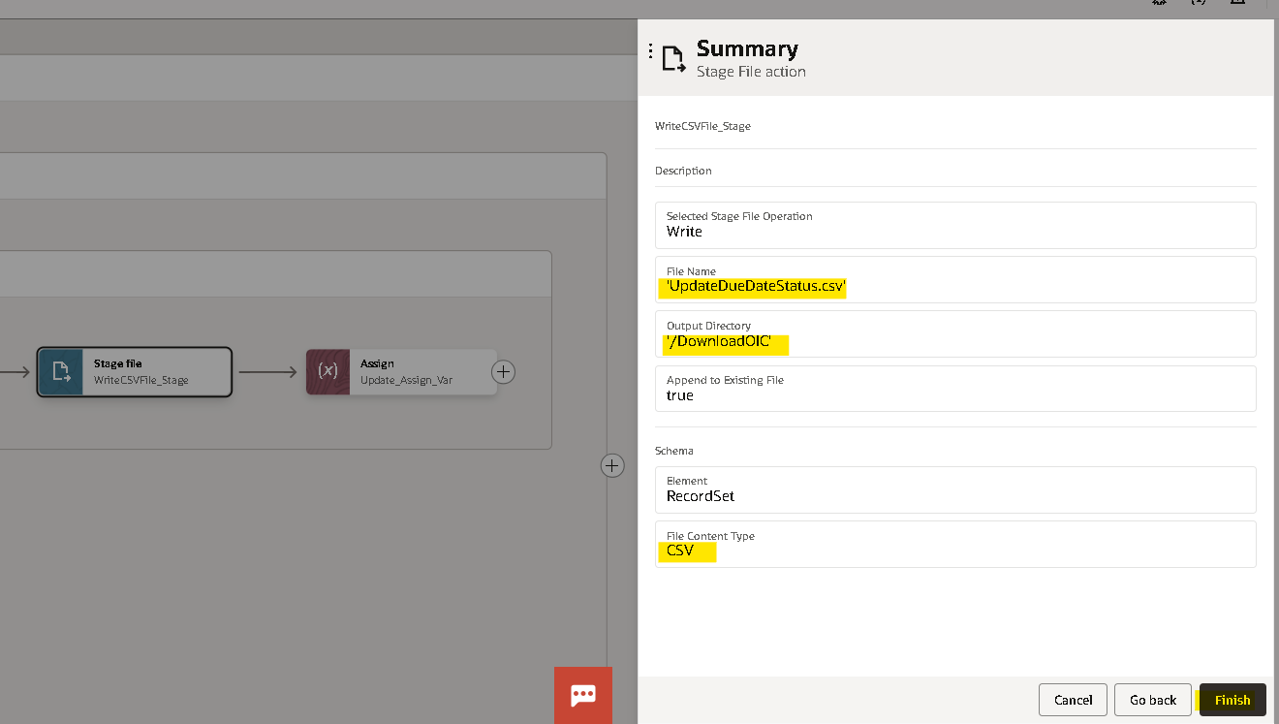
- Now edit the mapper of ‘writer CSV_file_Stage map the current record columns to target fields and create a target node for the column status and hardcode with success.
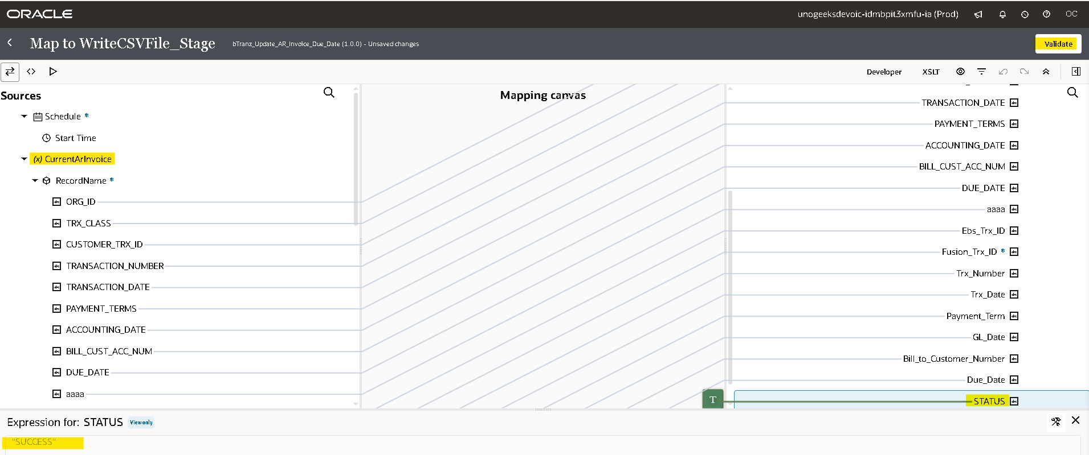
- Now we will update the UpadteDueDateFileRef variable with the response of the WriteFile_Stage operation by using assign activity
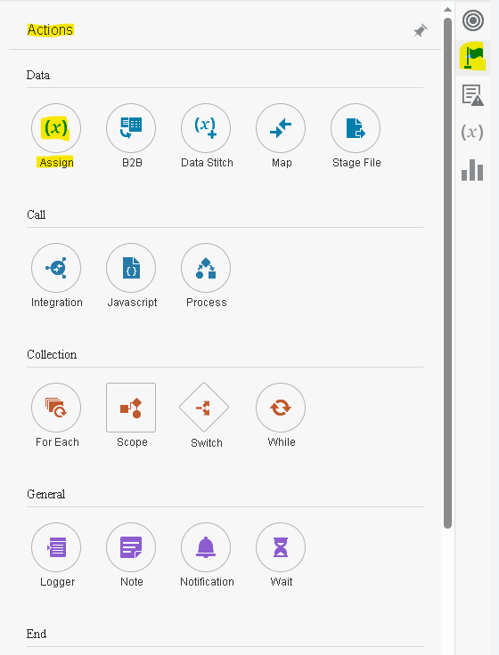
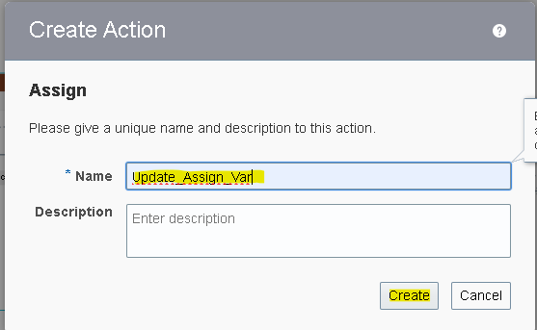
- By clicking on plus(+) icon it will create a variable then from the drop down select the variable which we want to update
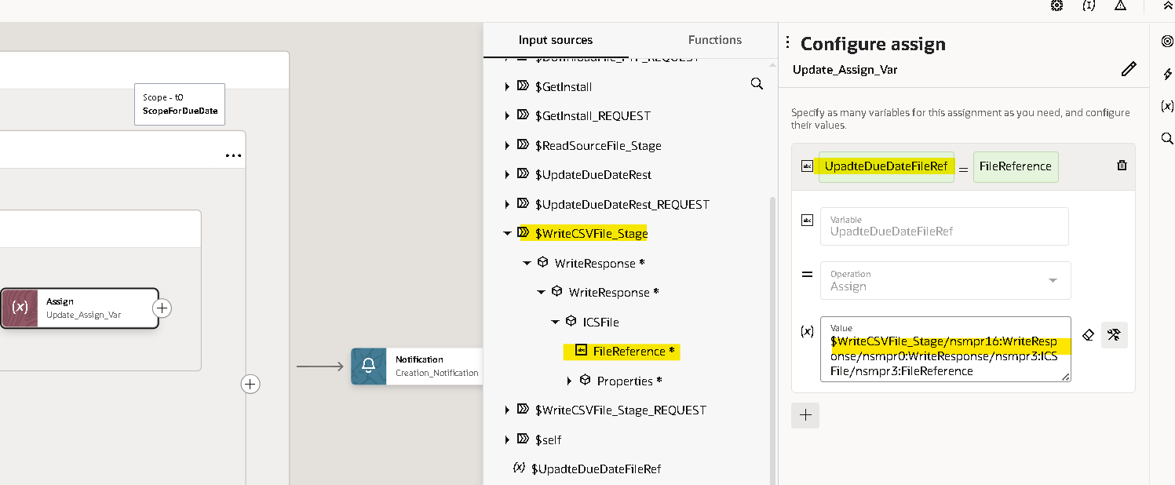

- Assign the FileReference from UpadteDueDateFileRef response.
- In Fault Handler use the stage write to write the error. (as done before for the success case) with status as ‘error’ and for error message we will map details of the ScopeForeEachRecordFaultObject details.
- Here we used substring function to get required part from error details.
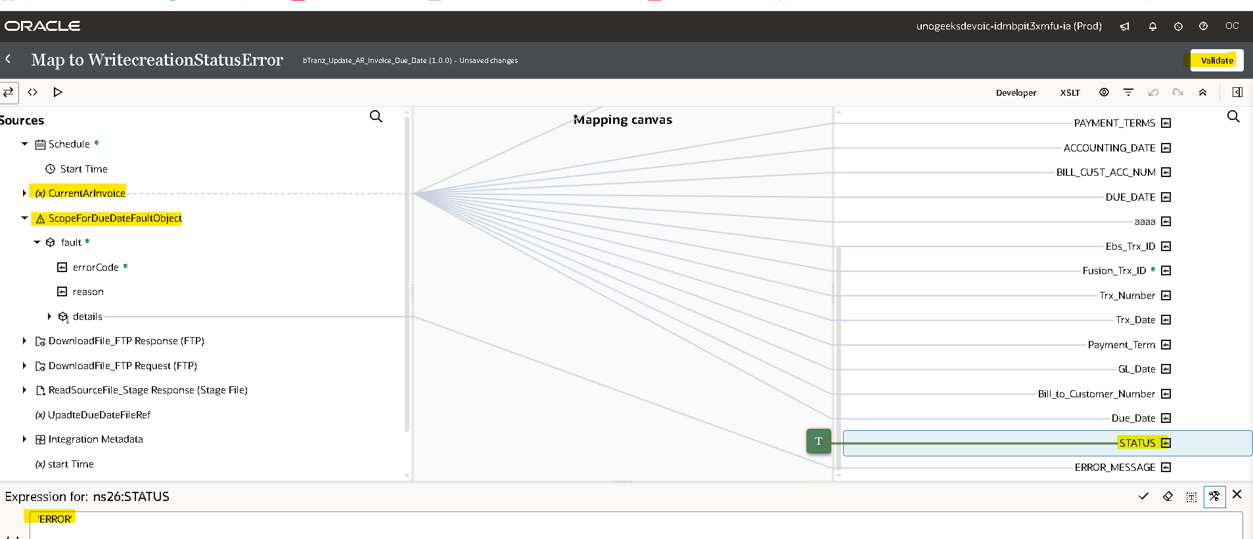
- Create an assignment variable and update the UpadteDueDateFileRef variable With FileReference of WritecreationStatusError response.
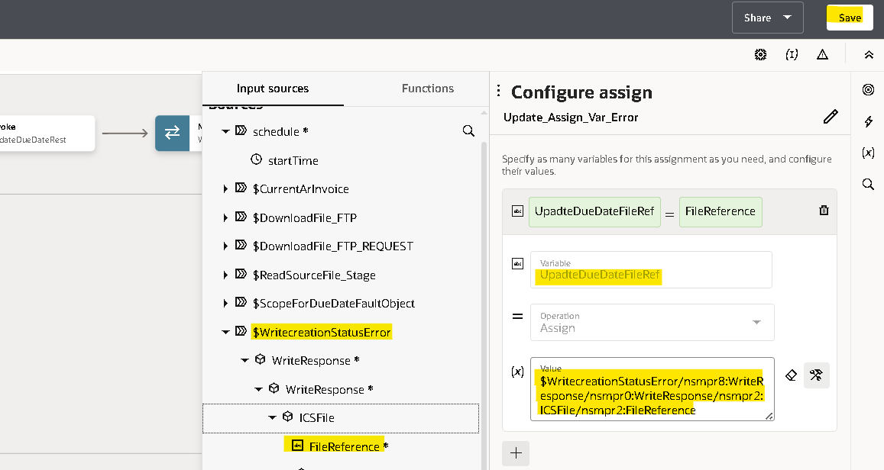

- Now we will use the notification activity to send a mail in message body we will send the InstanceId of the integration and Filename.
- Drag the notification action on the outside of both the scopes.
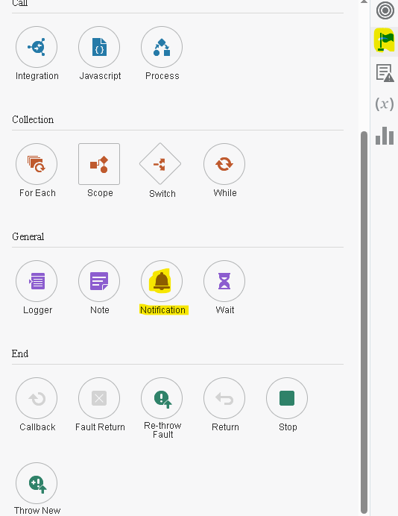
- You can provide the details as per your requirement.
- In message body if you need to pass the InstanceId and filename you need to create a parameter and then you can use those parameters by enclosing with flower brackets as shown below.
- Once you enter all the details validate and close the notification.
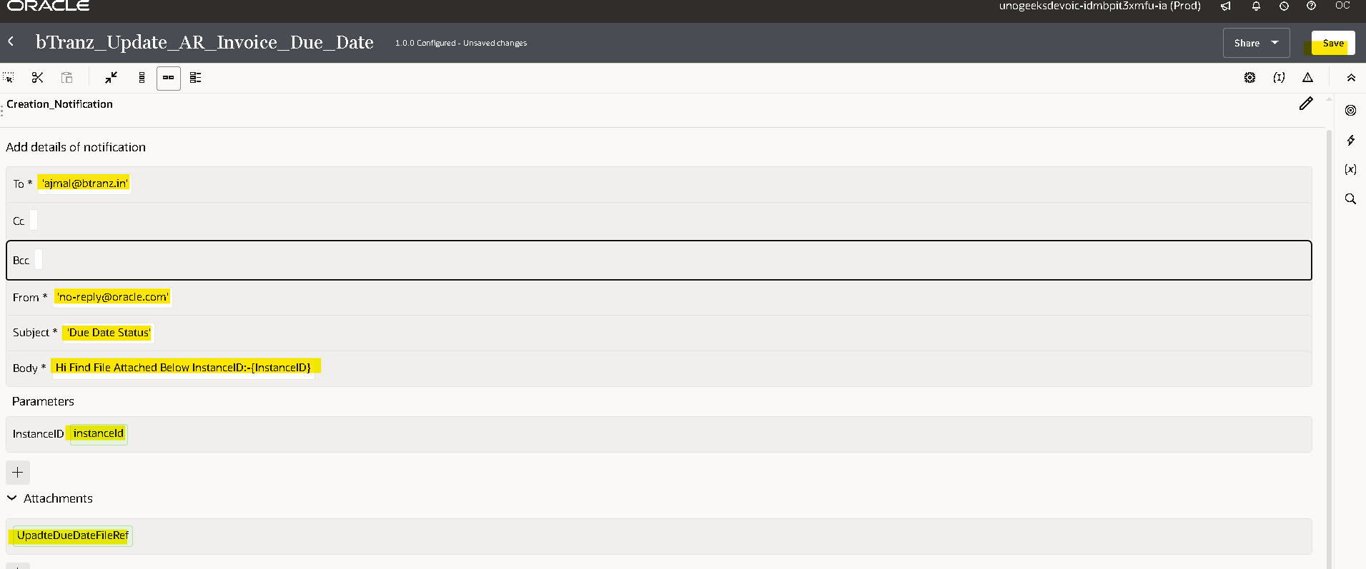
- For every integration we need to assign at least one tracking variable maximum we can assign up to three as it will be used when we are tracking the integration. here you can observe the error.
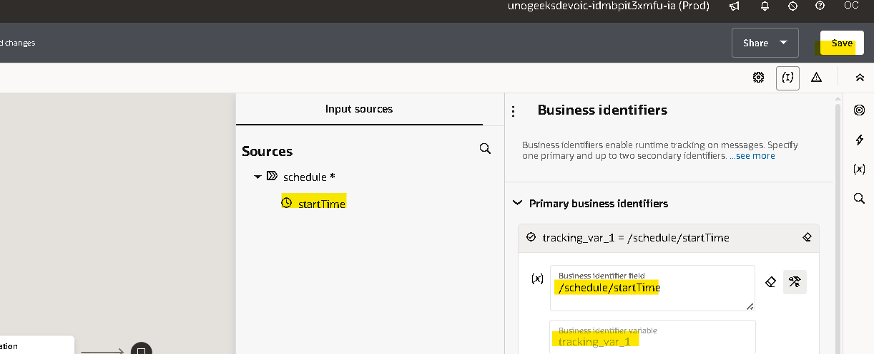
- Drag any variable from source to Tracking Field to mention it as Primary variable.
- Once you declare the tracking variable save and close the integration.
Running The Integration:

- Before running an integration, we need to activate it initially it will be in draft state after successful creation it will be in configured state after activating it will be in active state.
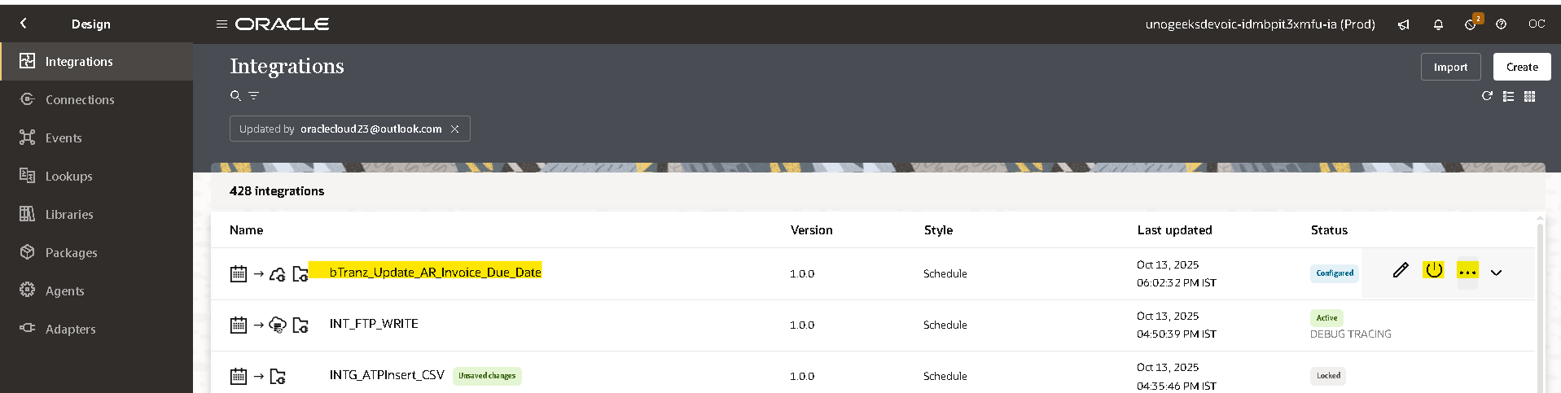
- You can activate and schedule as per your requirement it will run, or you can just activate directly.
- By checking include debug option it helps you to check the payload of each operation in tracking page.

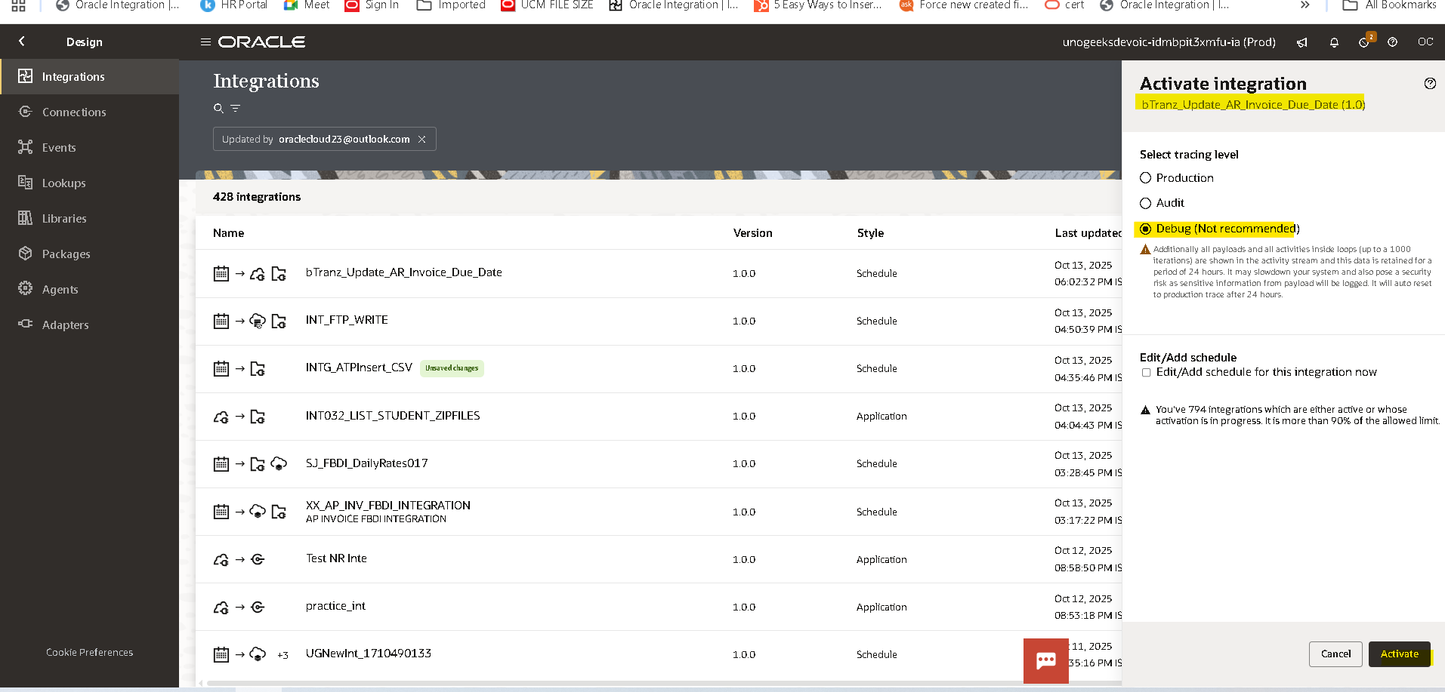
- By clicking on the three Dots and click on run
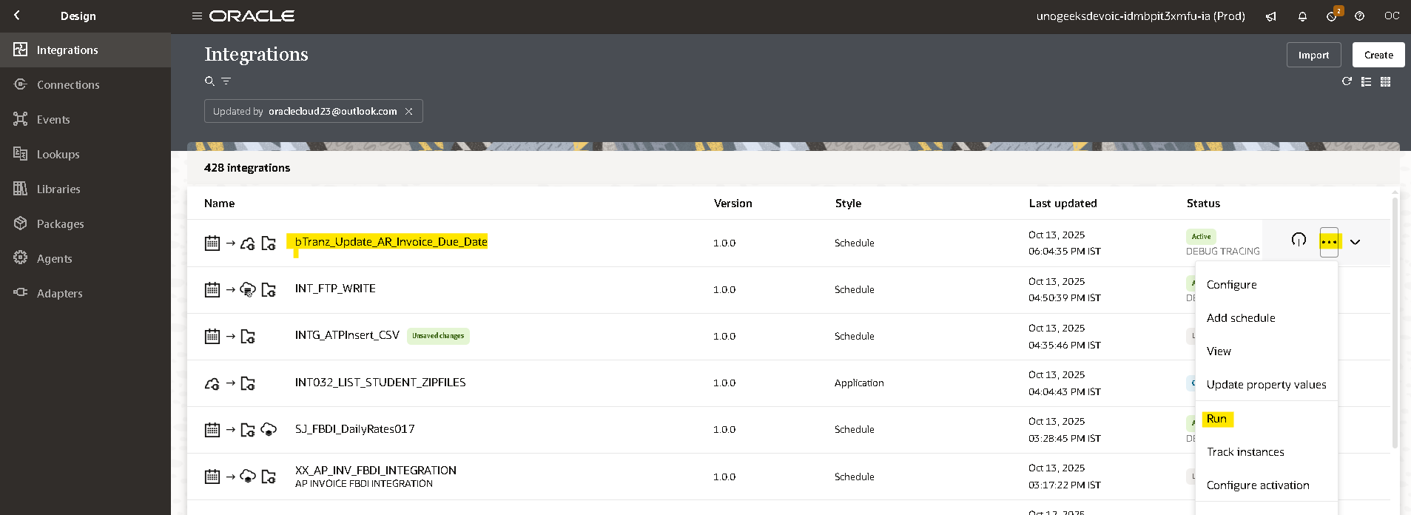
- Click on run again to submit instance to run.
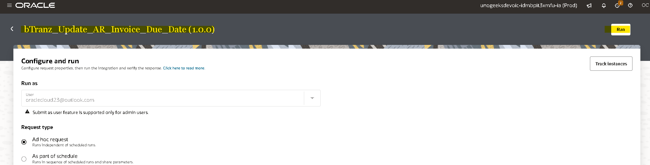
- You will get an InstanceId when you run the integration by clicking on that instance id you will be redirected to tracking page where you can check the status of that integration.
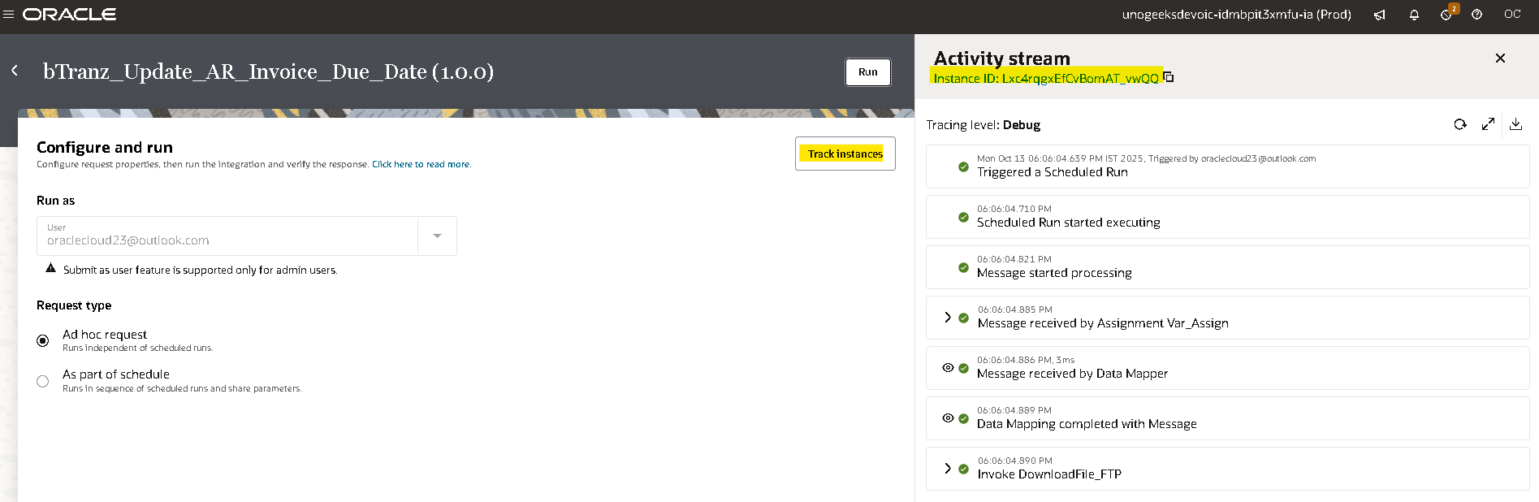

Tracking The Integration:

- To track the integration manually ObservabilityInstances
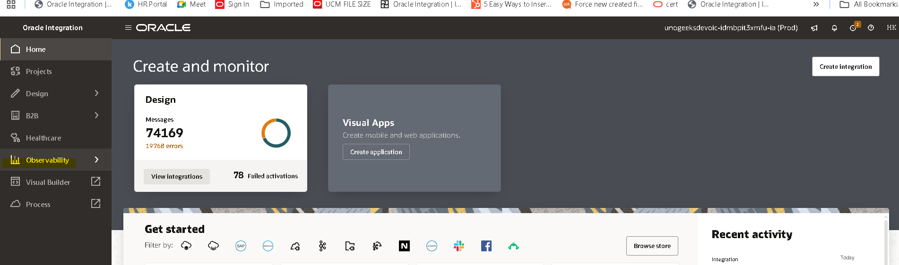
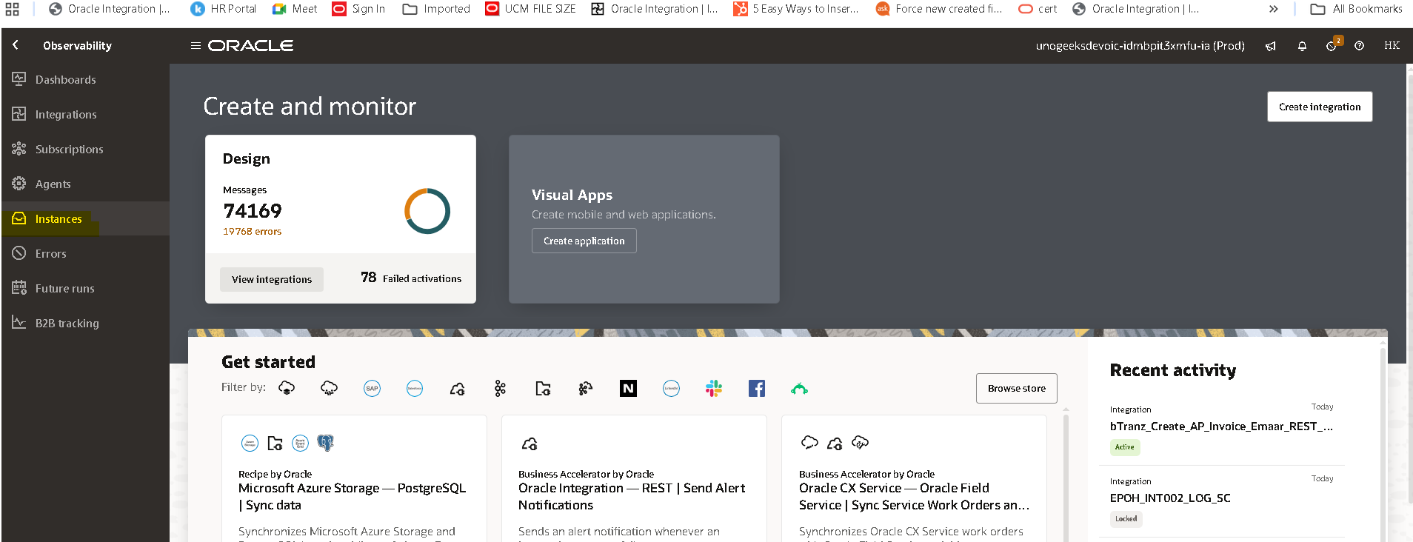

- Here you can observe the InstanceId and status of the integration (if you clicked on InstanceId while
running the integration, you will be redirected here)
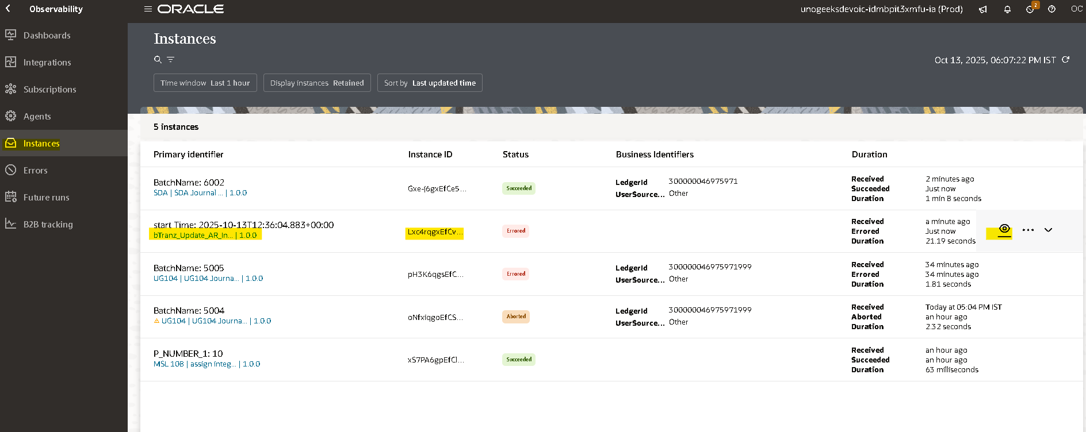
- By clicking on instance id in activity stream you can check the flow of the integration.
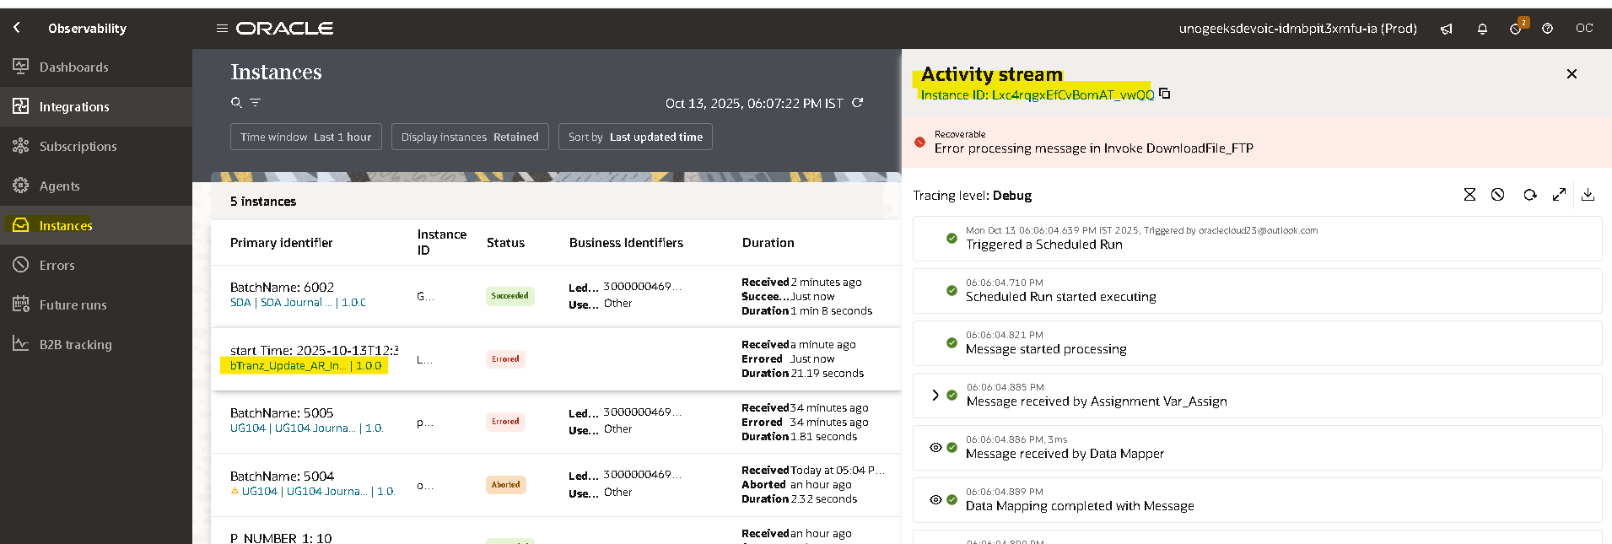

Open and Closed Issues for this Deliverable

Open Issues

ID | Issue | Resolution | Responsibility | Target Date | Impact Date

Closed Issues

ID | Issue | Resolution | Responsibility | Target Date | Impact Date

